PROJECT PLAN

< ONLINE SHOP STORE>

Revision History

|  |  |  |  |
| --- | --- | --- | --- |
| **Date** | **Version** | **Description** | **Author** |
| <14/06/2023> | 1.0 | <Prepare for project, planning> | <Trịnh Hoàng An> |
| <03/07/2023> | 2.0 | <Fixed some problem> | <Trịnh Hoàng An> |
|  |  |  |  |
|  |  |  |  |

# Introduction:

## 1.1 Purpose:

The purpose of the Online Book Store project is to create a digital platform where customers can easily browse, search, and purchase books online. The aim is to provide a convenient and user-friendly experience for book enthusiasts, making it effortless to explore a wide range of books and make secure transactions.

## 1.2 Scope:

The scope of the Online Book Store project includes the development of a website that offers a diverse collection of books across various genres and categories. The platform will provide features such as book browsing, searching, personalized recommendations, customer reviews, and secure payment options. The scope also encompasses the creation of user accounts to manage preferences, wishlists, and order tracking.

### 1.3 Definitions, Acronyms, and Abbreviations:

* Online Book Store: Refers to the digital platform developed for browsing, searching, and purchasing books online.
* Customers: Individuals who visit the online book store to explore and purchase books.
* Genres: Categories or types of books, such as fiction, non-fiction, romance, mystery, etc.
* Personalized Recommendations: Tailored book suggestions based on user preferences and browsing history.

# Project Overview:

## 2.1 Project Purpose:

The purpose of the Online Book Store project is to establish an efficient and user-friendly platform for customers to browse, search, and purchase books online. The project aims to cater to the increasing demand for digital book purchasing and provide a convenient solution for book enthusiasts worldwide.

## 2.2 Scope and Objectives:

The scope of the project includes the development of a comprehensive online book store website with features such as book categorization, search functionality, book descriptions, customer reviews, secure payment options, and personalized recommendations. The objective is to create an intuitive and seamless user experience that allows customers to easily find and purchase their desired books.

Assumptions:

* It is assumed that there will be a sufficient supply of books available from various publishers and authors.
* Customers will have access to a stable internet connection to browse and make purchases on the online book store platform.
* The online book store will adhere to relevant copyright laws and licensing agreements for selling digital books.

Constraints:

* The project is subject to budgetary constraints that may impact the implementation of certain features or marketing efforts.
* The development team's resources and expertise may impose limitations on the complexity and scope of certain technical functionalities.

## 2.3 Project deliverables

The following deliverables will be produced during the project:

* User interface design
* Product Management System
* Search function
* Shopping cart and payment
* Rating and commenting system
* User Account Management
* Integrated sharing and storage on social networks
* Integrated online reading feature
* Advertisements and promotions
* Order management and shipping
* Book warehouse management system
* Suggestion and customization system
* Ensure confidentiality and information

## 2.4 Evolution of the Software Development Plan

The development of a software development plan typically goes through the following stages and processes:

* Collect request
* Demand survey
* Planning
* Project Design
* Project development test run
* Deploy the project model
* Maintenance and support for errors during project running

# Project Organization:

## 3.1. Organizational Structure

Project Manager 🡪 Creative designer and developer 🡪 Product and quality manager 🡪 Marketers and Advertisers 🡪 Data Analyst 🡪 Tester 🡪 Financial manager

## 3.2. External Interfaces

The project team will work with marketers and advertisers to gather requirements and review appropriate for the site.

## 3.3. Roles and Responsibilities

The following table shows the roles represented in the project diagram above and their primary responsibilities.

|  |  |
| --- | --- |
| Role | Responsibilities |
| Project Manager | The Project Manager strategically directs, decides on policies and ensures that the website's operation achieves business goals. |
| Creative designer and developer | Creative designers and developers work together to develop and implement a website that sells books, creating an attractive and user-friendly interface for the website |
| Product and quality manager | Ensure the quality of the website by conducting quality checks and ensuring compliance with regulations and standards. Ensure that product information is always up-to-date and accurate on the website. |
| Marketers and Advertisers | Responsible for developing marketing and advertising strategies to attract new customers and increase sales. They can advertise on online channels, advertise directly with partners and develop innovative marketing campaigns. |
| Data Analyst | Responsible for collecting and analyzing data related to the operation of the website. They use analytics tools to understand user behavior, purchasing trends, and provide analytics and reports to support business decisions. |
| Tester | The Tester is responsible for executing testing, including test set-up and execution, evaluation of test execution and recovery from errors, and assessing the results of test and logging identified defects |
| Financial manager | Manage the financial activities of the website, including managing budgets, paying suppliers, processing payment transactions, and preparing financial reports. |

# Management Process

# 4.1 Project Estimates

## 4.2 Project Plan:

### 4.2.1 Project Phases: Every project will have 3 phases (Inception, Elaboration and Construction) and 5 Iterations / 5 Sprints (5 PAs).

**- Inception:** Establish the business case for the system: Selling books online.

**- Elaboration**: Develop an understanding of the problem domain and the system architecture.

**- Construction:** System design, programming and testing:

**5 Sprints:** One iteration or sprint = 2 weeks

**Inception**  
Week 1, 2: Project plan, vision document, weekly report

**Elaboration**

Week 3 – 6 (two sprints) :

- Revised project plan  
- Revised vision document  
- Use case document with a revised use case model  
- Design document (including UI prototypes, architecture document)  
-Test plan  
- Weekly reports  
**Construction**  
Two sprints (4 weeks)  
Week 7 – 10:Revised artifacts submitted in Elaboration

* Test cases
* Source code
* Test report
* Defects
* Weekly reports
* Final review – week 11 (likely after the final exam)
* Presentation + Demo

|  |  |  |  |  |  |
| --- | --- | --- | --- | --- | --- |
| **Phase** | | **No. Of Iterations** | **Start** | | **End** |
| Inception Phase | | 1 | 10/06/2023 | | 24/06/2023 |
| Elaboration Phase | | 1 | 25/06/2023 | | 08/07/2023 |
| Construction Phase | | 2 | 09/07/2023 | | 05/08/2023 |
| **Description** | | | **Milestone** | | |
| Inception Phase | | | The Inception Phase will analyze and research the environment that the software needed to execute through articles and resources online. After that will decide what function is able to do and what not and plan the process of building the software. | | |
| Elaboration Phase | | | The Elaboration Phase will develop the architectural prototype of the software. This version (prototype) will design and analyze all of the main use cases such as buying the books, sign up, log in.... Also test cases for making sure to release a stable alpha version. This version will be the foundation for the next phase. | | |
| Construction Phase | | | The Construction Phase will develop all the functions that the software requires based on the foundation that the Elaboration Phase releases. After developing all the functions, the beta version will be released for testing. There will be testing and bug-fixing for the most at the end of the Construction Phase. | | |

|  |  |  |
| --- | --- | --- |
| **Phase** | **Iteration** | **Objectives** |
| Inception | Preliminary Iteration | Define product requirements, project plan and vision document. |
| Elaboration | Setup environment and develop Alpha (Prototype) | -Complete analysis and design for all use cases, basic Web UI.  -Setup database server.  -Combine and develop the prototype - alpha version. |
| Construction | Develop Beta | - Implement and test all main use cases.  - Develop the Beta Version |
| Bug-fixing / Develop Release | - Implement and test sub use cases.  - Fix bugs, optimize and incorporate feedback from Beta Version  - Develop the Release Version |

4.2.2 Project Iterations/Sprints:

Specify how many builds you will produce for testing and when you will produce. There are 3 crucial builds, including:

- Home page for signing in and registing an account – for 1st week after the first sprint for planning project (estimated time).  
- Idication of books and selected books on the website – for the several following weeks – about 2-3 weeks (estimated time).  
- Ordering books and paying procession – about 2-3 weeks (estimated time).

Note**:** This phases could deploy simultaneously and be revised by members for every week for extending and fixing features.

### 4.2.3 Project Schedule

**Trello:**

**Activity Timeline / Staff allocation (estimated time):**

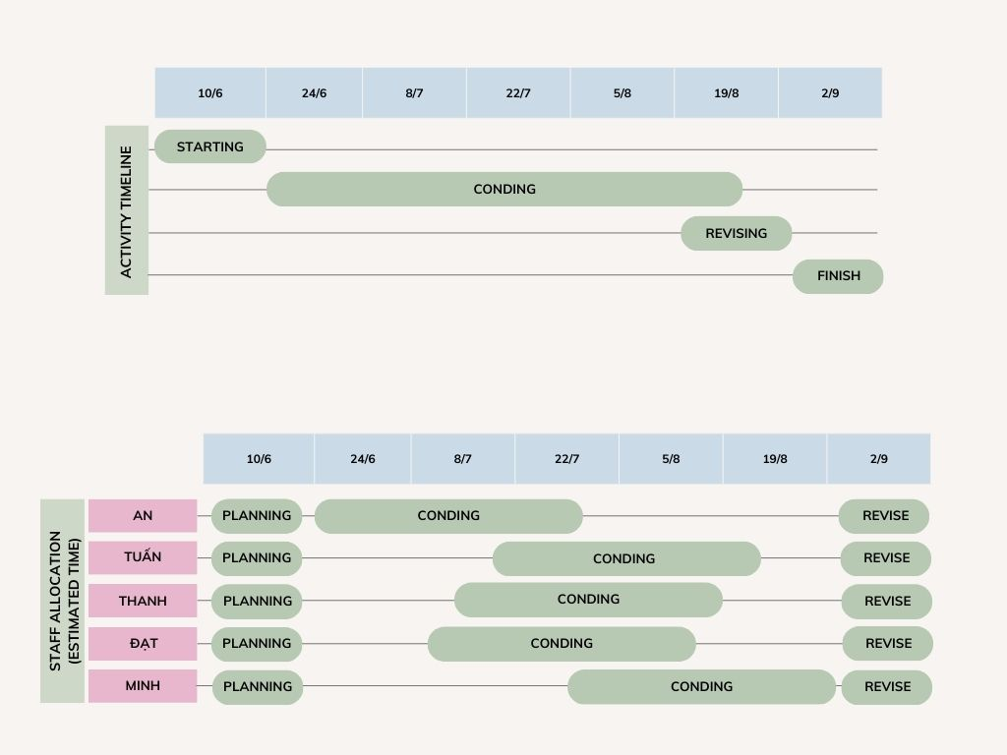

# 4.3 Project Monitoring and Control:

4.3.1 Tracking Progress:

|  |  |  |  |  |
| --- | --- | --- | --- | --- |
| **Phase** | **Iteration** | **Start-date** | **End-date** | **% Complete** |
| Inception | Preliminary Iteration | 10/06/2023 | 24/06/2023 | 100% |
| Elaboration | Setup environment and develop Alpha (Prototype) | 25/06/2023 | 08/07/2023 | 80% |
| Construction | Develop Beta | 09/07/2023 | 23/07/2023 | _ |
| Bug-fixing / Develop Release | 24/07/2023 | 05/08/2023 | _ |
| Finalizing documents - Preparing for presentation | | 09/08/2023 | 19/08/2023 | _ |

4.3.3 Risk Management:

Risk Identification:

Risk Identification:

* Conduct a thorough analysis of the project to identify potential risks. This includes reviewing project requirements, dependencies, and external factors.
* Engage stakeholders, project team members, and domain experts to gather their inputs and insights on potential risks.
* Utilize historical data and lessons learned from similar projects to identify common risks.

Risk Assessment:

* Assess the identified risks based on their likelihood of occurrence and potential impact on the project's objectives.
* Prioritize risks based on their severity and their potential to disrupt project timelines, budget, quality, or scope.
* Categorize risks into different types such as technical, organizational, external, or operational risks.

Risk Mitigation:

* Develop risk mitigation strategies for each identified risk. These strategies should aim to reduce the probability or impact of risks.
* Assign responsibility to appropriate team members for implementing risk mitigation measures.
* Implement preventive actions to address risks proactively, such as conducting additional testing, implementing security measures, or establishing backup systems.

Risk Monitoring and Control:

* Regularly monitor and review identified risks to track their status and evaluate the effectiveness of mitigation measures.
* Establish a risk register to document and track all identified risks, their current status, assigned owners, and mitigation actions.
* Conduct periodic risk assessments to identify new risks or changes in the severity of existing risks.
* Implement a change management process to address emerging risks or changes in risk priorities.

Risk Communication:

* Maintain open and effective communication channels with stakeholders to keep them informed about identified risks, mitigation strategies, and their progress.
* Provide regular risk status updates and reports to project sponsors, team members, and other relevant stakeholders.
* Encourage proactive reporting of potential risks or concerns from all project participants.
* Foster a culture of risk awareness and encourage the sharing of lessons learned and best practices related to risk management.

Table Of Content

1. Introduction: 1

1.1 Purpose: 1

1.2 Scope: 1

1.3 Definitions, Acronyms, and Abbreviations: 1

2. Project Overview: 1

2.1 Project Purpose: 1

2.2 Scope and Objectives: 1

2.3 Project deliverables 2

2.4 Evolution of the Software Development Plan 2

3. Project Organization: 2

3.1. Organizational Structure 2

3.2. External Interfaces 2

3.3. Roles and Responsibilities 3

4. Management Process 3

4.1 Project Estimates 3

4.2 Project Plan: 3

4.2.1 Project Phases:. 3

4.2.2 Project Iterations/Sprints: 5

4.2.3 Project Schedule 5

4.3 Project Monitoring and Control: 6

4.3.1 Tracking Progress: 6

4.3.3 Risk Management: 7